

Dr. Melissa, Sellers inc.

2022-06-15

Dr. Sellers

2606 Adam Courts, Port Jessicaborough, MD 61462

Phone: 3833538232

Fax: 135259262

**Re:** Mary, Tran

**PHN:** 3676450498

**Birthdate:** 18-Oct-1953

**Address:** 578 Castillo Estates Apt. 376, Danielville, NH 71240

**Patient number:** 8364382829

To Whom It May Concern:

This is a medical letter to state the above patient is pregnant with expected delivery date of 19-Aug-2025. Hoping this information is satisfactory for your requirements.

Thank you.

Sincerely,

Dr. Melissa, Sellers

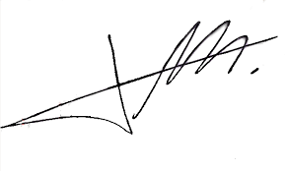

FRCS© NCMP

Clinical Assistant Professor, UBC

Department of Obstetrics and Gynecology SMH